Day 2: Emulators for Android Development, lots of choices

There are bunch of options to run your Android Application virtually in an emulator. Today, we will cover the best options that we have when doing Android Development with Xamarin –

1. Built in Android Emulator that comes with Android SDK
2. Xamarin Android Player
3. Geny Motion
4. Visual Studio 2015’s Android Emulator

## Built in Android Emulator

The Android SDK comes with a mobile emulator, although it’s slow. Like REALLY slow. There are ways to speed up the emulator when running on an X86 or X64 machines using Intel’s HAXM Drivers. But if I were to make a choice, I would just avoid it altogether, there are better options available and I will explore them in this post.

## Xamarin Android Player

Xamarin has an Android Emulator called [Xamarin Android Player](https://xamarin.com/android-player) which is fast. Like REALLY fast. Xamarin’s Android Player has options to create multiple emulators, options to reset the emulator device, duplicate it and support for multiple screen types and resolutions. At the time of this writing Xamarin Android Player has about 8 different devices that you can download and I can only imagine the list will grow in future to a lot more. 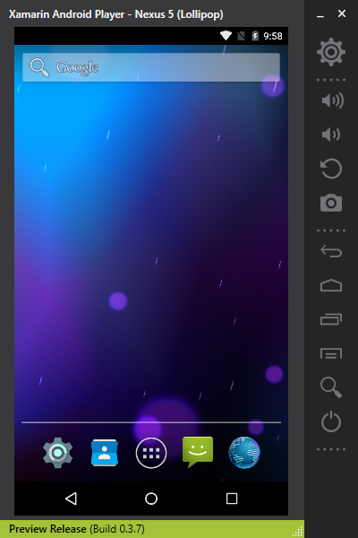

Xamarin Android Player also has options to control Battery settings, GPS locations, camera and device orientation. Overall, it’s a pretty impressive option and did I mention, its FREE?

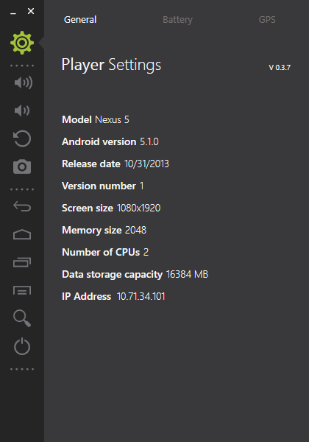

## Geny Motion

[Geny Motion](https://www.genymotion.com/) is a “faster” Android Emulator. It supports pretty much every single option that you would want from an Emulator, if not more.

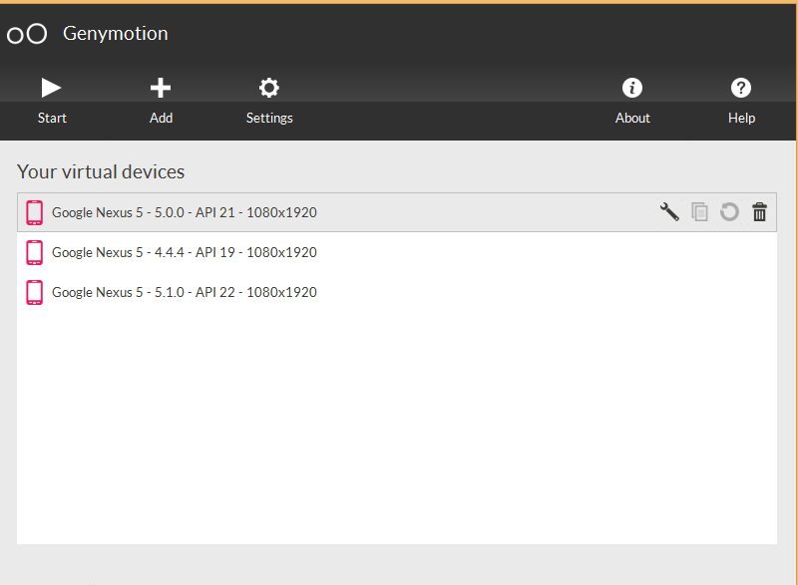

It has a long list of devices it supports over multiple screen size and resolutions and Android OS versions. It supports GPS, Camera, Volume, Drag and Drop and many more.

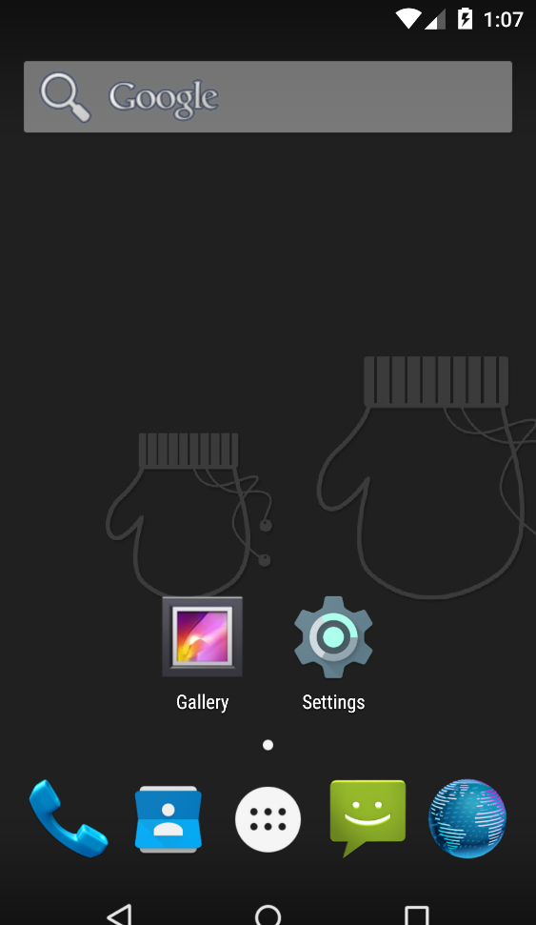

Geny Motion is free for personal use and has a paid subscription model for businesses. Do Checkout their store for pricing information.

## Visual Studio 2015’s Emulator

The Microsoft we have known over the years is changing, with the latest version of Visual Studio 2015, Microsoft ships an Android emulator that is not only fast but is a first class citizen inside Visual Studio.

## Options on Mac

Xamarin’s Android Player and Geny Motion work on Mac and are still fantastic options when developing Android apps on a Mac.

I personally use Xamarin’s Android Player a lot but during this series you will see me switch between multiple options that I outlined here.

Tomorrow, we will create our first Android App with Xamarin.

Venkata